DL Lab Exp No.4 (Mini Project)

1. Colourizing B&W to colourful images:

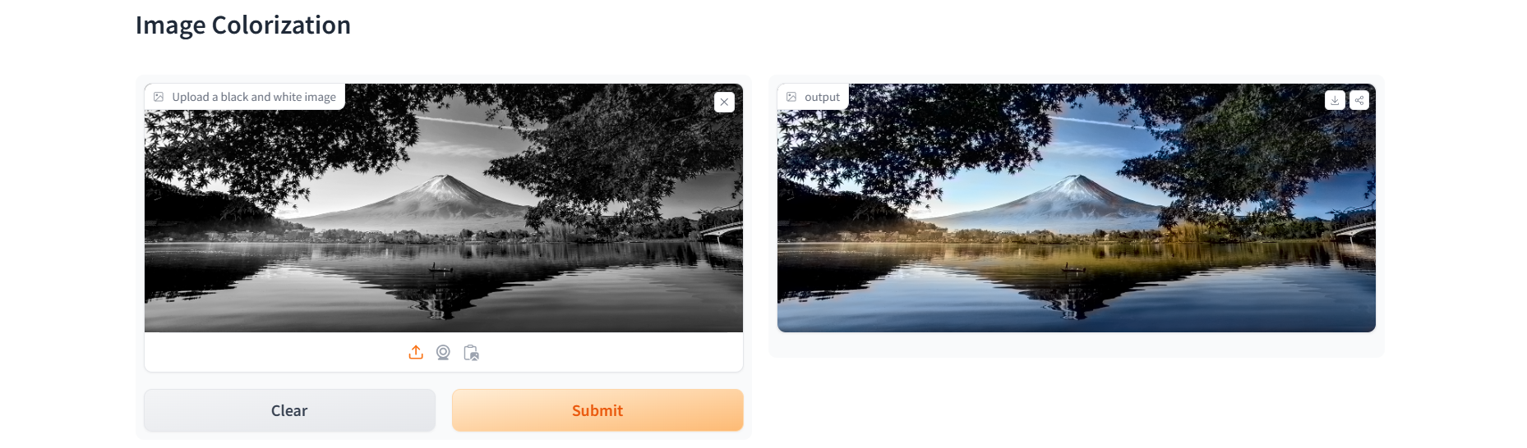

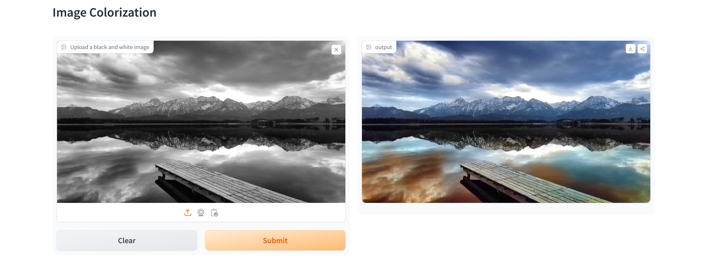

1. Gender and Age Detection:

